HYDRAULIC RATED BUCKET CYCLE TIMES AND FIELD DUTY CYCLE TIMES OF MINING SIZE WHEEL LOADERS – A Case Study
Metin ÖZDOĞAN
Hakkı ÖZDOĞAN
Abstract:
Rated hydraulic cycle time (H-CT) of a wheel loader is defined, examples are given and illustrated. It comprises of rackback, hoist, dump and float (lowering) phases of an empty bucket. It is an indicative figure showing the hydraulic speed and capability of a loader which is in the range of 20-25 seconds depending on the size of the equipment. The actual field duty cycle time (F-CT) is about double the hydraulic cycle time because of the fact that the equipment ought to travel to dig, dig and travel to dump with full bucket load.
Segments of H-CT and F-CT are given and depicted. Percentages of segments in full H-CT and F-Ct are given and discussed.
Two cases from the Americas an one from Turkey are given and depicted. Furthermore, factors affecting the field duty cycle times with respect to digging forces and ground engaging tools are cited and discussed.
Key Words: Mining size wheel loaders, Hydraulic cycle time, Segments of Hydraulic cycle time, Field duty cycle time, Field duty cycle time segments, Hydraulic cycle time to field duty cycle time ratios, Digging forces, Ground engaging tools.

INTRODUCTION
Mining size wheel loaders are major and/or standby workhorses of open-pit mines and quarries. They are mobile, versatile digging and loading equipment. The loaders even act as load and haul equipment in short haul distances to bunkers of ore dressing plants or coal washeries. As far as the capital cost of a mining wheel loader is concerned, it is omparatively cheaper and life expectancy is comparatively shorter (30,000 h).
Rated hydraulic cycle of a wheel loader with an empty bucket (with no payload) is defined as to rackback, raise (hoist), dump and lowering of the bucket. Some manufacturers include the rackback time into hoisting phase. Rated hydraulic cycle time of mining and quarry size wheel loaders vary from 21 seconds to 26 seconds depending on the size of the loader. However, the field duty cycle times are almost double the rated hydraulic cycle times. It is expected to have higher field cycle times since the bucket has a payload in it and the loader has phases like to travel to dig (TTDG), travel to dump (TTDMP).
One of the drawbacks of mining wheel loaders is having comparatively higher field cycle times than that of hydraulic excavators due to it’s design. The loader has to move back and forth in fullfilling its duty cycle; travel to dig (TTDG), dig (DG), travel to dump (TTDMP) and dump (DMP) for completing its duty cycle. Since it has not got a slewing upper frame rotating on a ring gear as in the case of hydraulic excavators (Özdoğan and Özdoğan, 2019).
On the other hand, hard digging conditions like compact and unblasted formations, tight loading areas and poor underfoot conditions such as unlevel, loose and wet benches unfavour the application of wheel loaders and result in higher duty cycle times due to longer (prolonged) dig time phases.
1. HYDRAULIC CYCLE TIMES OF SOME WHEEL LOADERS
Rated hydraulic cycle times (H-CT) of wheel loaders comprise of rackback (curling, tilting) and hoist (raise), dump, and float (lowering) of the empty bucket by definition. It is a rated cycle time specific to the loader in question indicating the hydraulic capability (power, speed) of the equipment, See Figure 1.
It is an indicative figure showing the hydraulic speed and capability of the loader which is in the range of 20-25 seconds depending on the size and made of the equipment. The actual field duty cycle time (F-CT) is about twice the hydraulic cycle time because of the fact that the equipment ought to travel to dig, dig and travel to dump with the payload. Field cycle times of wheel loaders vary from 30 to 45 seconds depending on the size and design, muckpile conditions, the layout of hauler and loader and skill and experience of operator. .

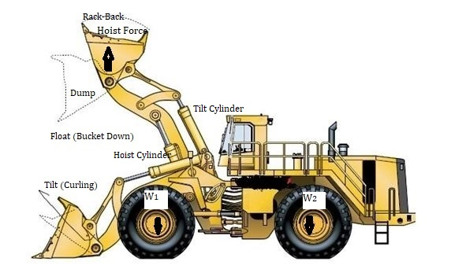
Figure 1. Hydraulic cycle time phases (Modified afterValintaopas & Kaivoslastaus, 2013)
Hydraulic cycle time is the rated time with empty bucket which includes phases like hoisting (raising), dumping and lowering (floating) the bucket. Raising bucket includes rack back motion of the bucket, See Figure 1.
Nominal hydraulic cycle time does not include the time spend in overcoming weight of rock material in the bucket to raise and resistance of rock bank to digging. In other words, H-CT excludes resistance to penetration, hoisting bucket (load) being filled and curling of bucket (rack-back) in rock material, furthermore, H-CT does not include the travel to dig and travel to dump segments’ times, either. Therefore, field cycle times of wheel loaders are much higher than that of rated hydraulic cycle times, as expected, See Figure 5,6, 7 and 8.????

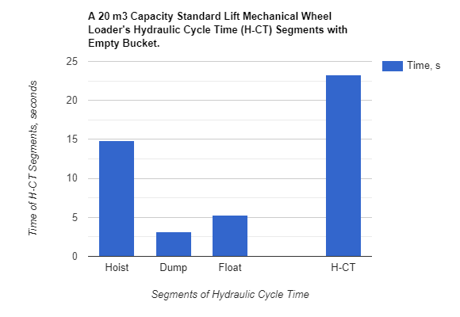
Figure 2. A 20 m³ mechanical Wheel loader’s hydraulic cycle time (Data Anon a, 2019).
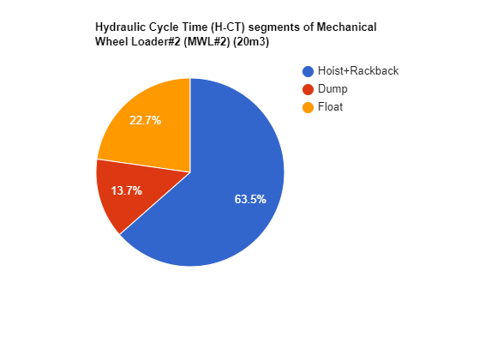
Figure 3. Hydraulic cycle time segment percentages of a 20m³ MWL (Data Anon a, 2019)

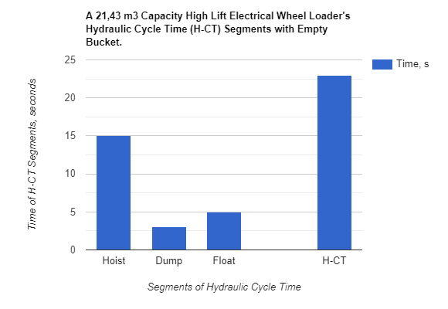
Figure 4. Hydraulic cycle time of an electric Wheel loader of 21,43 m³ bucket (Data Anon b, 2019).

Table 1a. Hydraulic CTs of some MWLs & EWLs (Data Anon a,b,c,d,e, 2019)
WL Models/ H-CT Segments | Cat994K (19,10 m³), s(MWL#1)  (Anon e) | WA-1200-6 (20 m³), s (MWL#2) | L-1150 (19,11 m³), s (EWL#1) | L-1350 (21,41 m³), s (EWL#2) | L-2350 (40,52 m³), s (EWL#3)
Hoist (Raise), s | 17,5 | 14,8 | 13 | 15 | 17
Dump, s | 3,1 | 3,2 | 3 | 3 | 3
Float (Lower), s | 4,2 | 5,3 | 5 | 5 | 6
H-CT, s | 24,80 | 23,3 | 21 | 23 | 26

Table 1aa. Hydraulic CTs of some MWLs & EWLs of 20 m³ range.
WL Models/ H-CT Segments | Cat994K (19,10 m³), s(MWL#1) | WA-1200-6 (20 m³), s (MWL#2) | L-1150 (19,11 m³), s (EWL#1) | L-1350 (21,41 m³), s (EWL#2) | Mean, s
Hoist (Raise), s | 17,5 | 14,8 | 13 | 15 | 15,08±1,85
Dump, s | 3,1 | 3,2 | 3 | 3 | 3,08±0,10
Float (Lower), s | 4,2 | 5,3 | 5 | 5 | 4,88±0,47
H-CT, s | 24,80 | 23,3 | 21 | 23 | 23,03±1,56

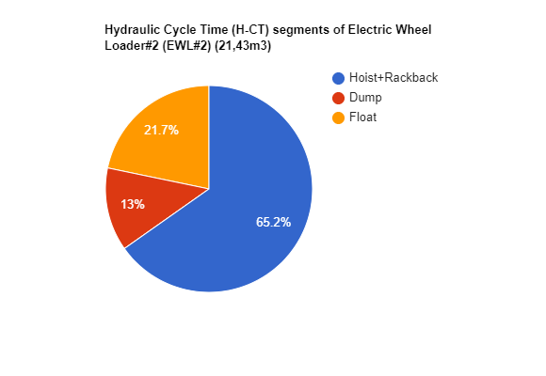
Figure 5. (Data Anon b, 2019) (21,43m³)
Hydraulic cycle time and segment facts and figures of some mechanical Wheel loaders (MWL) and Electric Wheel Loaders are given in Table 1.
Table 1b. H-CT segments to H-CT ratios of some mechanical and electric Wheel loaders of 20 m³ bucket range.
WL Models/ Segment/ H-CT Ratios (%) | Hoist (Raise)/ H-CT (%) | Dump/ H-CT (%) | Float (Lower)/H-CT (%) | H-CT, s
Cat994K (19,10 m³), s(MWL#1) | 70,57 | 12,50 | 16,94 | 24,80
WA-1200-6 (20 m³), s (MWL#2) | 63,52 | 13,73 | 22,75 | 23,3
L-1150 (19,11 m³), s (EWL#1) | 61,91 | 14,29 | 23,81 | 21
L-1350 (21,41 m³), s (EWL#2) | 65,22 | 13,04 | 21,74 | 23
Mean | 65,08±4,05 | 13,39±0.78 | 21,31±3,03 | 23,03±1,56

Table 1bb. H-CT segments to H-CT ratios of some mechanical and electric Wheel loaders of 20 m³ bucket range.

WL Models/ Segment/ H-CT Ratios (%) | Rackback/ H-CT (%) | Hoist (Raise)/ H-CT (%) | Dump/ H-CT (%) | Float (Lower)/H-CT (%) | H-CT, s
Cat994K (19,10 m³), s(MWL#1) | 19,76 | 51,61 | 12,50 | 16,94 | 24,80
WA-1200-6 (20 m³), s (MWL#2) | Included into Hoisting | 63,52 | 13,73 | 22,75 | 23,3
L-1150 (19,11 m³), s (EWL#1) | Included into Hoisting | 61,91 | 14,29 | 23,81 | 21
L-1350 (21,41 m³), s (EWL#2) | Included into Hoisting | 65,22 | 13,04 | 21,74 | 23
Mean | N/A | 60,57±6,12 | 13,39±0,78 | 21,31±3,03 | 23,03±1,56

2. FIELD CYCLE TIME OF SOME WHEEL LOADERS
Field cycle times of wheel loaders are much higher than the rated hydraulic cycle times with empty buckets. Hydraulic cycle times do not include bucket payloads, travel to dig and travel to dump times.

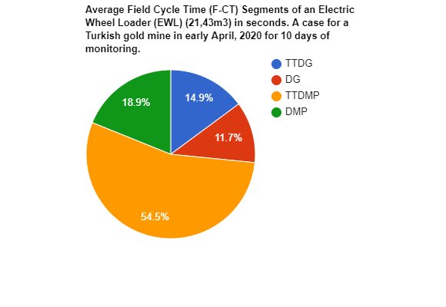
Figure 7. (21,43m³)

The field duty cycle times include Travel to Dig (TTDG) and Travel To Dump (TTDMP) and Dig (DG) times, payload and resistance of rock material to penetration, hoisting and rackback which are realized with load in bucket. That is why field cycle times are much higher than the hydraulic CT with empty bucket.
Table .. L-1350 (21.43m3) 10 days of average daily monitoring results of a electric Wheel loader at a gold mine in Turkey in April, 2020.

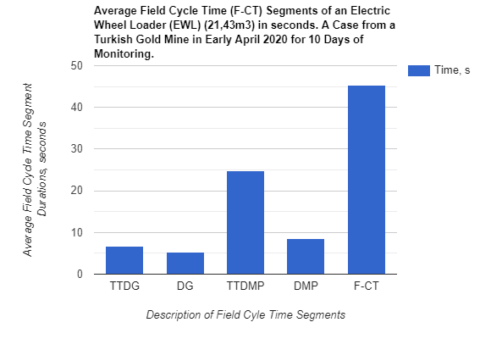
Figure 8. A 20m³ range electric wheel loadersfield CT components.

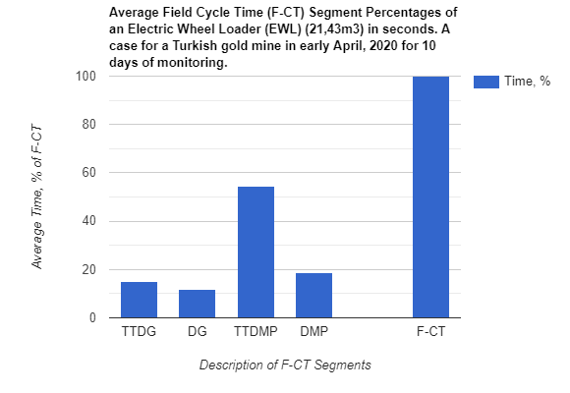
Figure 9. Ratio of field cycle time segments to full F-CT
Field cycle time cases of three loading operations from Turkey are given in Table 3 and Table 4.
Equipment | CT Hydraulic, s | Date and Daily Average Field CT, s |  |  | Average Field CT, s | Ratio of H-CT to F-CT (%)
L-1350 TR02case#1 (Feb.2020) (21,43m³) | 23 sec | 44,86 sec | 45,01 sec | 41,45 sec | 43,77±2,01 | 0,526±0,025
Date | Feb.12-13,2020, Feb.13-14,2020 & Feb.16-17, 2020
Date | April1-2, 2020 to April 19-20, 2020
L-1350 TR02case#2 (April 2020) (21,43m³) | 23 sec |  |  |  | 45,40±1,17 | 0,487±0,061
Date | March 20-March 31, 2018
L-1350 TR01case#1 | 23 |  |  |  | 44,11±1,80 | 0,522±0,018

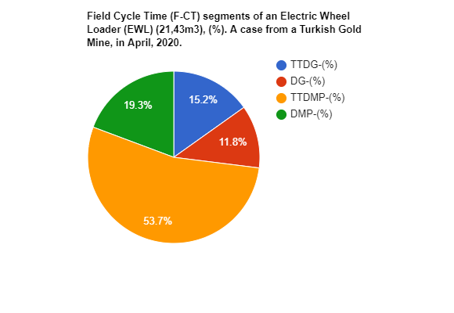
Figure … TR 2020
For the case monitored in Turkey in April, 2020 for 10 days, the average field cycle time phase percentages depicted in Fig … above. The majority of the field cycle time, 73%, is spent in Travel To Dump (TTDMP) and Dump (DMP) phases. The remaining 27% comprises of Travel To Dig (TTDG) and Dig (DG) segments. This fact implies that travel to dump and dump are cumbersome since it is performed by the full bucket (loaded bucket).

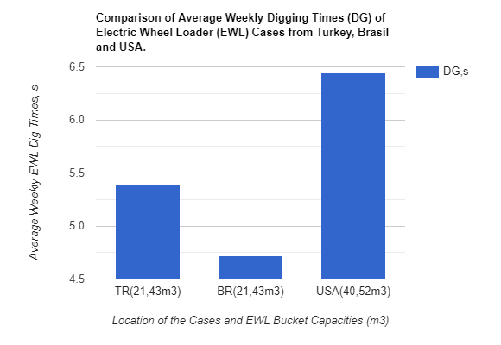

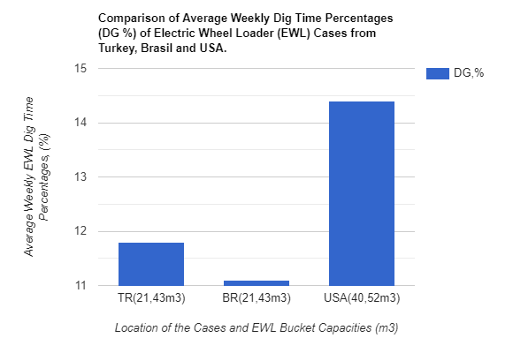
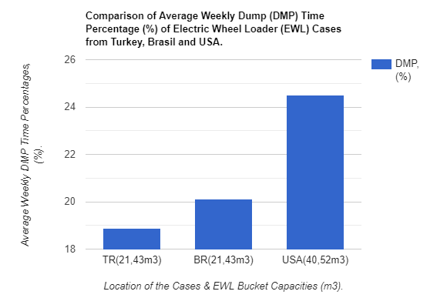
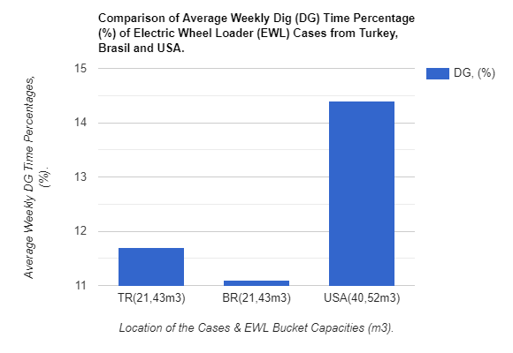
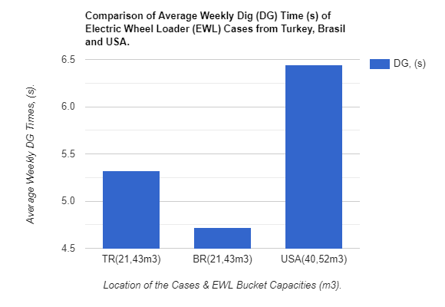
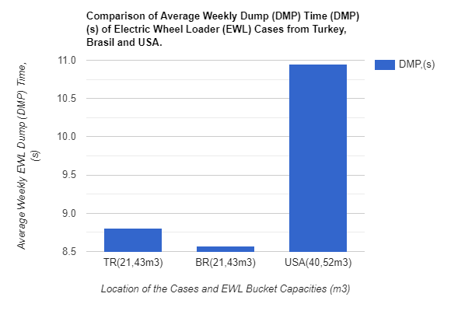
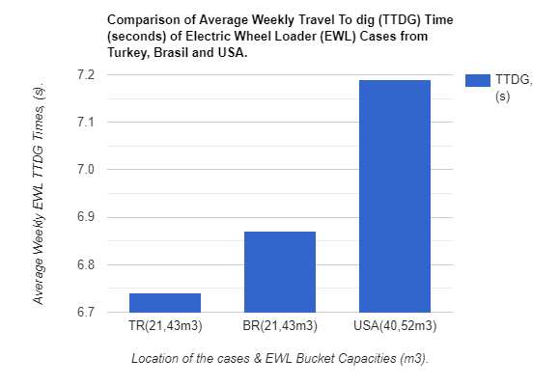
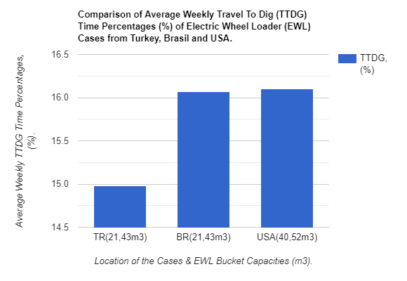

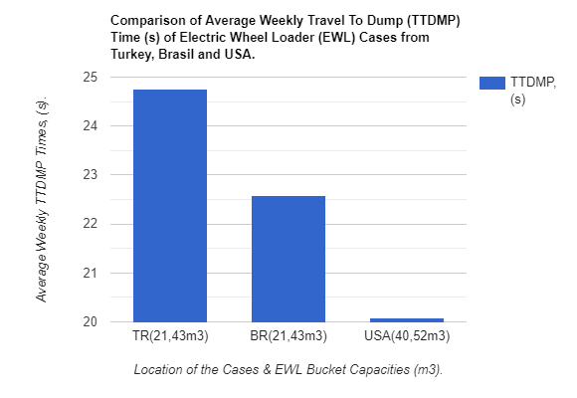
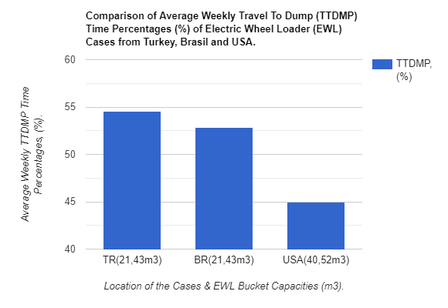

Table 4aa L-1350 Turkey
Period/ Segments | TTDG, s | DG, s | TTDMP, s | DMP, s | CT, s
Overall Mean TR | 6,74±0,39 | 5,32±0,24 | 24,75±1,08 | 8,57±0,76 | 45,40±1,17

Table 4bb L-1350 Turkey
Segment % in CT/  Period | TTDG/ CT(%) | DG/CT (%) | TTDMP/ CT (%) | DMP/CT (%) | PYLD, t
Overall Mean TR% | 14,98±1,18 | 11,70±0,36 | 54,54±2,07 | 18,88±1,52 | 30,30±1,42

The higher the digging forces, the quicker the dig time, thus the field duty cycle time of the loader. The field duty cycle times include Travel to Dig (TTDG) and

3. H-CT TO F-CT RATIOS OF SOME MINING SIZE WHEEL LOADERS
Table.. H-CT to F-CT ratios of Wheel loaders monitored.
Model▼ CT► | H-CT, s | F-CT, s | H-CT/F-CT (%)
L-1350 (TR)(302) | 23 | 45,40±1,17 | 0,487±0,061
L-1350 (BR) | 23 | 42,74±2,11 | 0,539±0,027
L-1350 (TR)(301) | 23 | 44,11±1,80 | 0,522±0,018
L-2350 (USA) | 26 | 44,67±1,15 | 0,583±0,015
Mean |  | 44,48±0,72 | 0,533±0,040

The higher the digging forces, the quicker the dig time, thus higher the field duty cycle time of the loader.
Model▼ CT► | H-CT, s | F-CT, s | H-CT/F-CT (%)
L-1350 (TR)(302) | 23 | 45,40±1,17 | 0,487±0,061
L-1350 (BR) | 23 | 42,74±2,11 | 0,539±0,027
L-1350 (TR)(301) | 23 | 44,11±1,80 | 0,522±0,018
L-2350 (USA) | 26 | 44,67±1,15 | 0,583±0,015
Mean |  | 44,48±0,72 | 0,533±0,040

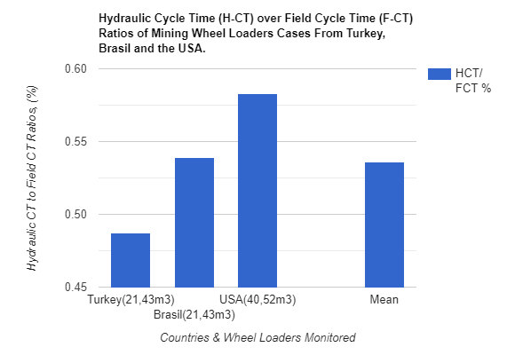
Figure …
Travel To Dump (TTDMP) and Dig (DG) times, payload and resistance of rock material to penetration, hoisting and rackback which are realized with load in bucket. That is why field cycle times are much higher than the hydraulic CT with empty bucket.
Table 4a. L-1350 (21,43m³) Weekly Report TURKEY, April 1-2, 2020- April 14-15, 2020
Period/ Segments | TTDG, s | DG, s | TTDMP, s | DMP, s | CT, s | HCT/CT (%)
Avg. Daily#1 | 6,51 | 4,94 | 24,73 | 6,76 | 43,03 | 23 / 43,03 0.54
Avg. Daily#2 | 6,37 | 5,30 | 25,75 | 8,58 | 46,01 | 23 / 46,01 0.50
Avg. Daily#3 | 6,89 | 5,66 | 25,87 | 8,61 | 46,97 | 23 / 46,97 0.49
Avg. Daily#4 | 7,29 | 5,68 | 24,53 | 8,46 | 45,95 | 23 / 45,95 0.50
Avg. Daily#5 | 7,14 | 5,55 | 24,30 | 9,60 | 46,56 | 23 / 46,56 0.49
Avg. Daily#6 | 7,14 | 5,28 | 22,76 | 9,00 | 44,22 | 23/44,22 0.52
Avg. Daily#7 | 6,73 | 5,23 | 23,19 | 9,30 | 44,54 | 23/44,54 0.52
Avg. Daily#8 | 6,34 | 5,21 | 25,46 | 8,31 | 45,34 | 23/45,34 0.51
Avg. Daily#9 | 6,81 | 5,10 | 25,33 | 8,34 | 45,64 | 23/45,64 0.50
Avg. Daily#10 | 6,13 | 5,23 | 25,61 | 8,76 | 45,73 | 23/45,73 0.50
Overall Mean | 6,74±0,39 | 5,32±0,24 | 24,75±1,08 | 8,57±0,76 | 45,40±1,17 | 0,51±0,02

Table 4aa L-1350 Turkey
Period/ Segments | TTDG, s | DG, s | TTDMP, s | DMP, s | CT, s | HCT/CT (%)
Overall Mean | 6,74±0,39 | 5,32±0,24 | 24,75±1,08 | 8,57±0,76 | 45,40±1,17 | 0,51±0,02

Table 4bb L-1350 Turkey
Segment % in CT/  Period | TTDG/ CT(%) | DG/CT (%) | TTDMP/ CT (%) | DMP/CT (%) | PYLD, t
Overall Mean | 14,98±1,18 | 11,70±0,36 | 54,54±2,07 | 18,88±1,52 | 30,30±1,42

Table 4b. L-1350 (21,43m³) Weekly Report TURKEY, April 1-2, 2020- April 14-15, 2020
Segment % in CT/  Period | TTDG/ CT(%) | DG/CT (%) | TTDMP/ CT (%) | DMP/CT (%) | PYLD, t
Avg. Daily#1 | 15,10 | 11,50 | 57,50 | 15,70 | 29
Avg. Daily#2 | 13,90 | 11,50 | 55,90 | 18,70 | 30
Avg. Daily#3 | 14,70 | 12,10 | 55,10 | 18,30 | 30
Avg. Daily#4 | 17,20 | 12,40 | 53,40 | 18,40 | 31
Avg. Daily#5 | 15,30 | 11,90 | 52,20 | 20,70 | 31
Avg. Daily#6 | 16,20 | 11,80 | 51,50 | 20,30 | 33
Avg. Daily#7 | 15,10 | 11,70 | 52,10 | 20,90 | 31
Avg. Daily#8 | 14,00 | 11,50 | 56,20 | 18,30 | 28
Avg. Daily#9 | 14,90 | 11,20 | 55,50 | 18,30 | 29
Avg. Daily#10 | 13,40 | 11,40 | 56,00 | 19,20 | 31
Overall Mean | 14,98±1,18 | 11,70±0,36 | 54,54±2,07 | 18,88±1,52 | 30,30±1,42

The field duty cycle times include Travel to Dig (TTDG) and Travel To Dump (TTDMP) and Dig (DG) times.
Table 5. Date and Daily Average Field CT s of cases from three countries.
Equipment | CT Hydraulic, s | Dig Time (DG), s | Bucket Payload (PYLD), tonnes | Average Field CT, s
L-1350 TR (21,43m3) | 23 sec | 5,32±0,24 | 30,30±1,52 | 45,40±1,17 sec
(7)A six day daily monitoring case from April 6-7 to April 13-14,2020, A case from a gold mine in Turkey)
L-1350 BR (21,43m3) | 23 sec | 4,72±0,34 | 29,00±1,00 | 42,74±2,11 sec
A weekly monitoring case during Feb 24,2015 to March 02, 2015 (A case from an iron mine in Brasil) (Ozdogan&Ozdogan, 2016).
.
L-2350 USA (40,52m3) | 26 sec | 6,44±0,63 | 49,50±0,71 | 44,67±1,15 s
A weekly monitoring case during March 20,2015 to April 05,2015 (A case from a coal mine in USA) (Ozdogan&Ozdogan, 2016).

Table … Comparison of field cycle time segments to full field cycle time ratios of the monitored three cases.
 | TTDG/F-CT (%) | DG/F-CT (%) | TTDMP/F-CT (%) | DMP/F-CT (%) | F-CT, s
L-1350 TR 21,43m³ | 14,98±1,18 | 11,70±0,36 | 54,54±2,07 | 18,88±1,52 | 45,40±1,17
L-1350 BR 21,43m³ | 20,70±2,70 | 11,10±1,30 | 50,50±3,30 | 20,10±2,90 | 42,74±2,11
L-2350 USA 40,52m³ | 16,10±2,70 | 14,40±1,00 | 45,00±1,10 | 24,50±2,60 | 44,67±1,15

4. CONCLUDING REMARKS
Hydraulic cycle time of a wheel loader is a rated manufacturing specification indicating the hydraulic power capability of the loading equipment with respect to its physical dimensions. Hydraulic cycle time of an empty bucket loader comprises of rackback (curling, tilting), raise (hoisting), dump and float (lowering) segments. Some manufacturers include rackback segment to hoisting (raising) phase. As a rule of thumb the larger the size of the loader, the higher the hydraulic cycle time is.
Average hydraulic cycle times of 20 m³ range mechanic and electric drive Wheel loaders studied is 23,03±1,56 seconds. Average durations of the phases are as follows: Hoist 15,08±1,85 seconds, dump 3,08±0,10 seconds and float is 4,88±0,47 seconds.
As far as the percentages of the phases are concerned, average of the values of the four Wheel loaders studied are as follows: Hoist % in H-CT is 65,08±4,05, dump % in H-CT is 13,39±0,78 and float % in H-CT is 21,31±3,03.

Model▼ CT► | H-CT, s | F-CT, s | H-CT/F-CT (%)
L-1350 (TR#1)(302) | 23 | 45,40±1,17 | 0,487±0,061
L-1350 (BR) | 23 | 42,74±2,11 | 0,539±0,027
L-1350 (TR#2)(301) | 23 | 44,11±1,80 | 0,522±0,018
L-2350 (USA) | 26 | 44,67±1,15 | 0,583±0,015
Mean | 23,75±1,50 | 44,48±0,72 | 0,533±0,040

Actual field cycle time figures are about twice the duration of hydraulic cycle times. Because of the fact that field cycle times includes the times consumed in travelling to dig and travelling to dump phases, and additionally it takes more time to raise a bucket with payload in it. Travel to dig and travel to dump phases of field cycle times depend on the truck and loader layout with respect to digging bench. Hydraulic cycle time to field cycle time ratios (H-CT/F-CT) of monitored loaders are as follows: L-1350 (TR#1) is 0,487±0,061, L-1350 (TR#2) is 0,522±0,018, L-1350 (BR) is 0,539±0,027 and L-2350 (USA) is 0,583±0,015. Hydraulic cycle times of the loaders are 23s, 23s, 23s and 26 seconds in sequence, whereas field cycle times are 45,40±1,17, 44,11±1,80, 42,74±2,11 and 44,67±1,15 seconds respectively.
Mean figures of H-CT, F-CT and H-CT/F-CT ratios of the monitored EWLs are 23,75±1,50, 44,48±0,72 and 0,533±0,040 in sequence.

Comparison of three 21,43 m³ bucket electric wheel loaders’ a week long monitoring results of field cycle times and segments, one at an iron ore mine in Brasil, the other two at a gold mine in Western Turkey give comparable figures. Average field cycle time of the case in Brasil is 42,74±2,11 seconds, whereas the cycle time figures in Turkey are 45,40±1,17 and 44,11±1,80 seconds. Slight differences in durations of phases and field cycle times are expected due to the layout of loaders with respect to bench (muckpile) and hauler, operator experience and skills and other site specific conditions. The collected data reveals that about 70 % of the field cycle time is spend (consumed) by Travel To Dump (50%) (TTDMP) and Dump (20%) (DMP) phases. As one may appreciate these two phases are the most difficult two segments of the duty cycle because the equipment has to travel to the hauler with full bucket load and the full bucket has to be raised to the truck body level for unloading. Therefore, it takes comparatively higher times to fullfill these phases. As a rule of thumb, it may be said that the remaining 30 % is shared by digging and travel to digging phases.
Loading is the central part of any earthmoving process. The entire system’s productivity is governed by the loading tool’s productivity in other words by the cycle times of the equipment. Cycle time is mainly governed by the digging force magnitudes of loading (earthmoving) equipment. As a rule of thumb, the higher the digging forces, the shorter the duty cycle time of the loading equipment assuming blasting and fragmentation of the material being loaded is optimum for the equipment.
The higher the traction between the tyre and ground surfaces, the higher the bucket penetration into the material being dug and loaded. Rain and contaminants have negative impacts on traction of tyres, whereas grip type tyre tread patterns and tyre protection chains have positive impact on the traction coefficient, thus increasing the bucket penetration into the rock material.
REFERENCES
Anon a, 2019: “Technical Specifications of WA-1200-6 HLFT Wheel Loader” MWL#1 (18m3)(&.40m) = WA-1200-6 HLFT https://www.komatsu.eu/en/wheel-loaders/wheel-loaders/wa1200-6
Anon b, 2019: “Technical Specifications of P&H L-1350 HLFT Wheel Loader” EWL#2 (21.43m3)(6.40m) = L-1350 HLFT https://mining.komatsu/product-details/l-1350
Anon c, 2019: “Technical Specifications of P&H L-1150 HLFT Wheel Loader,” EWL#1 (17.58m3)(5.49m) = L-1150 HLFT https://mining.komatsu/product-details/l-1150
*Anon d.., 2019: “Technical Specifications of P&H L-2350 Wheel Loader” https://mining.komatsu/product-details/l-2350
*Anon e.., 2019: “Technical Specifications of P&H L-1850 Wheel Loader” https://mining.komatsu/product-details/l-2350
Anon f, 2019: “Technical Specifications of PC 4000” HSHV#1, https://komatsu-mining.de/products/pc4000/
Filla, R., 2014 : “A Study to compare generation algorithms for automatic bucket filling in Wheel loaders” Commercial Vehicle Technology Symposium, March 2014, Kaiseralutern, Germany. DOI: 10.13140/R.G.2.1.3604.2723 https://www.researchgate.net/publication/260059023_A_study_to_compare_trajectory_generation_algorithms_for_automatic_bucket_filling_in_wheel_loaders

Valintaopas & Kaivoslastaus, 2013: “Surface Mining Primary Loading Tool” Loading Equipment Selection, Cat Dealers, Finland. https://www.witraktor.com/sites/default/files/media/Finland/Koneet/Kaivoskoneet/PDFs/valintaopas_kaivoslastauslaitteet.pdf

Özdoğan M.& Özdoğan H., 2020 : “Digging Forces of Hydraulic Backhoes” DOI: 10.13140/RG.2.2.14392.90882. IMMB Journal, January-February-March 2020 Ankara, ISSN 1306-6943, İş makinaları Mühendisleri Birliği Dergisi.

Özdoğan M.& Özdoğan H., 2019 (a) : “ Tekerlekli Yükleyici Kepçelerinin kazı Kuvvetleri ve Makinanın Dengesini Etkileyen Kuvvetler” İMMB Dergisi, Temmuz-Ağustos-Eylül 2019, Sayı : 67, pp : 50-56, Ankara, ISSN 1306-6943, İş makinaları Mühendisleri Birliği Dergisi.
Özdoğan M.& Özdoğan H., 2019 (b) : “Hidrolik Küreğimsi Yer-Kazıcılar ve Kepçe Kazma Kuvvetleri” İMMB Dergisi Ekim-Kasım-Aralık 2019, Sayı : 68, pp. 48-54, Ankara, ISSN 1306-6943.
*Özdoğan M. & Özdoğan, H., 2016: “ Improvement of cycle Times of Electric Wheel Loaders Through hand on Operator Training- A case Study”, 29th Turkish Coal congress, May 2016, Zonguldak, Turkey.
Grant, M. 2016 : “ Hydraulic Shovel vs Wheel loader, Quarry Academy, USA. https://www.911metallurgist.com/blog/wp-content/uploads/2016/01/Hydraulic-Shovel-vs-Wheel-Loader.pdf
Özdoğan, M., 2002 : “ Elektrikli Yerkazı Makinalarının Kazı Gücü Etkileyicileri ve Karşılaştırma Ölçütleri”, Bilimsel Madencilik Dergisi. 2002; 41(4): 10-3.

